Step 1: Create a Frame or Shape and run Text around them

The easiest way to set up your document for text-wrapping is to position your text frame(s) behind the image frame or shape you want to apply the text wrap effect to. This means you can easily select your frame/shape.
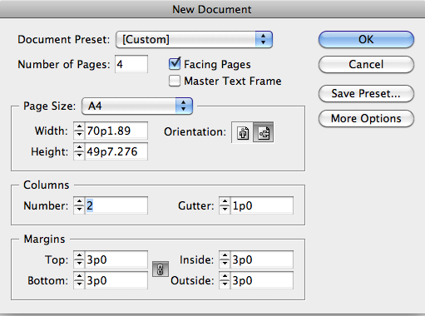
In this example, I have created two columns of text using the Type Tool (T), threading the text between them by clicking once on the bottom right corner of the left-hand column, then once again in the right-hand column.
Load a lot of text (See http://www.peterfaulks.net/Teaching/Tutorials/miscellaneous.html) Text Large Block Lorem Ipsum.doc
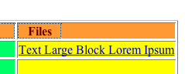

Click Place, find the text Large Block Lorem Ipsum.doc and open it, a Text Holder will appear holding the text.
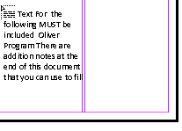
In the first Page left column click the text holder to
release the text
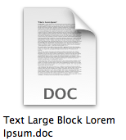

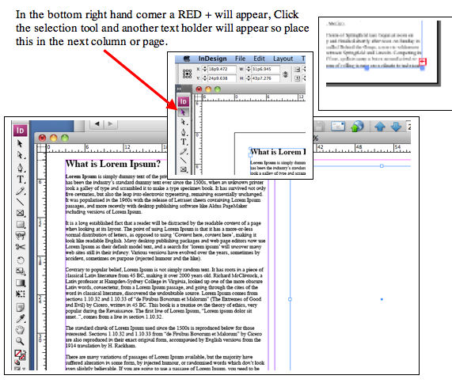

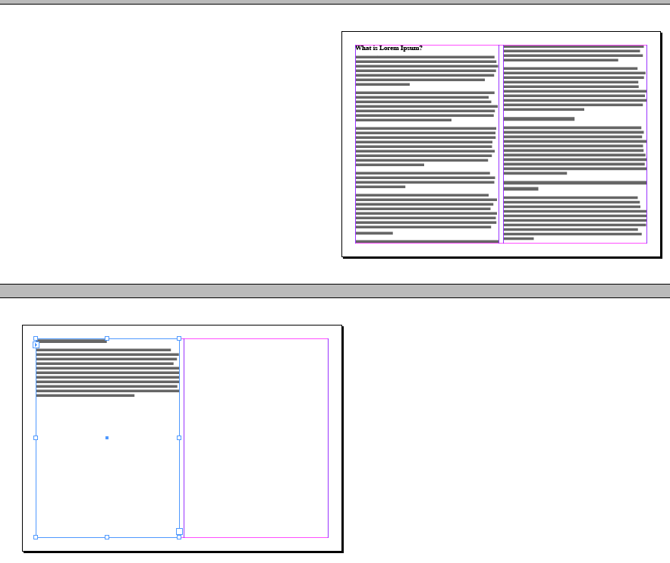
The text is now inserted throught our document, Of course you can select AUTOFLOW which will automatically flow all text through your document.
Holding down Shift, position the loaded text icon in the upper left corner of the left
column on page 2, and click. Release the Shift key.
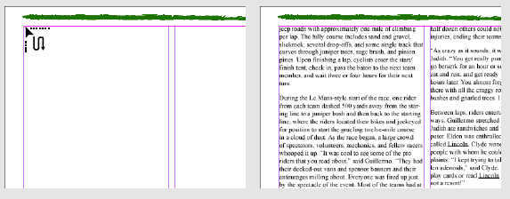Holding down Shift lets you autoflow text into your document.
Then I selected the Rectangle Frame Tool (F)
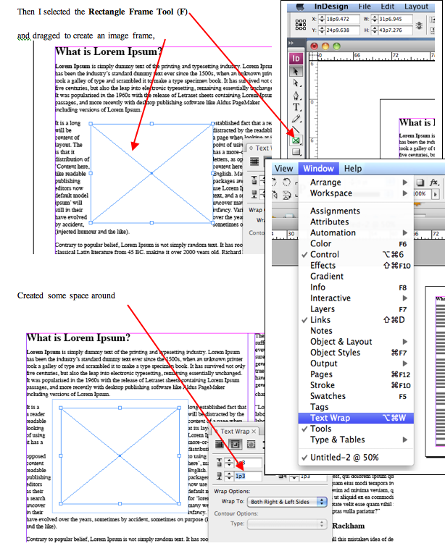

Step 2: Open the Text Wrap Panel

Select the image frame or shape and go to Window > Text Wrap to open the Text Wrap Panel.
Across the top of the panel there are five icons, each of which indicate a different way of applying the text wrap. The icon to the far left, selected by default, has No Text Wrap applied to your frame/shape. Click on the second icon along from the left to apply a wrap around the Bounding Box of the frame/shape.
You can adjust the Offset values to increase or decrease the distance between the text and the edge of your frame/shape.

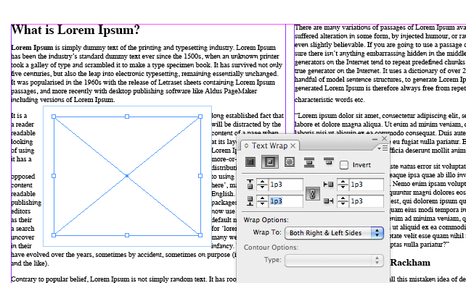

Find a small picture any .jpg will do (See end of this document)
You can also adjust the direction of the wrap from the Wrap Options drop-down. menu
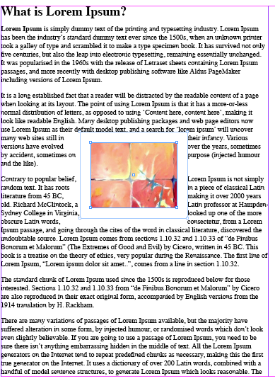
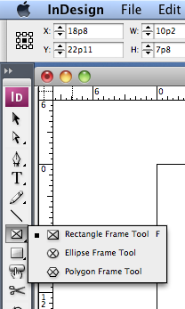

Add a circular frame and creat som space around this

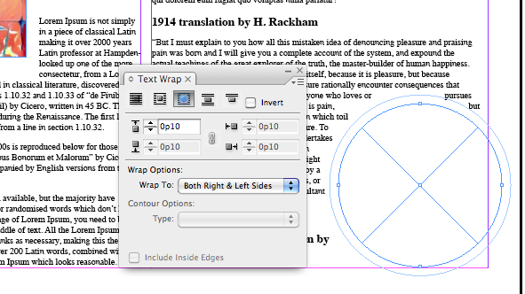
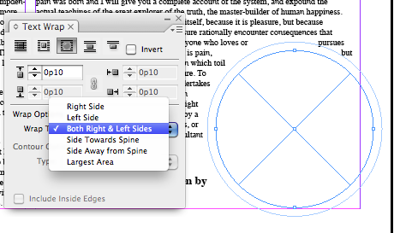
Add an image (Place) to this frame
Experiment with different ways of applying a wrap using the icons in the Text Wrap Panel. You can wrap text around an Object’s Shape to give a more closely fitted appearance to the wrap. This can work particularly well with outlined text (Type > Create Outlines), which gives a dramatic typographic effect.
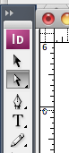
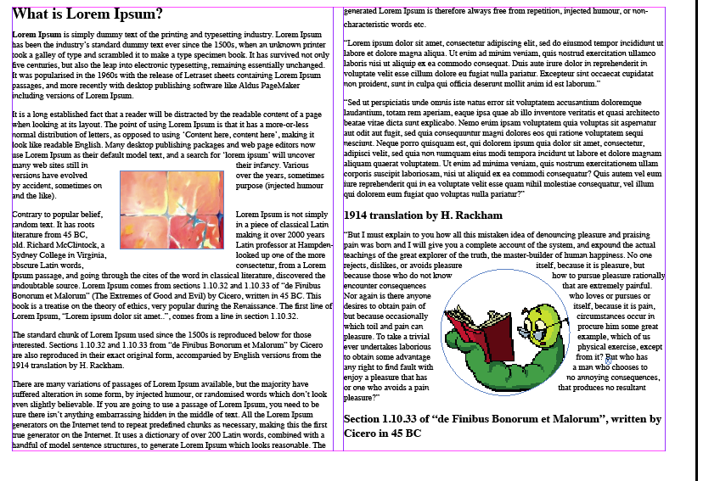

Play with the wraps using Direct Setection Arrow Tool click on the poins on the edge of the frame, to shape them

